












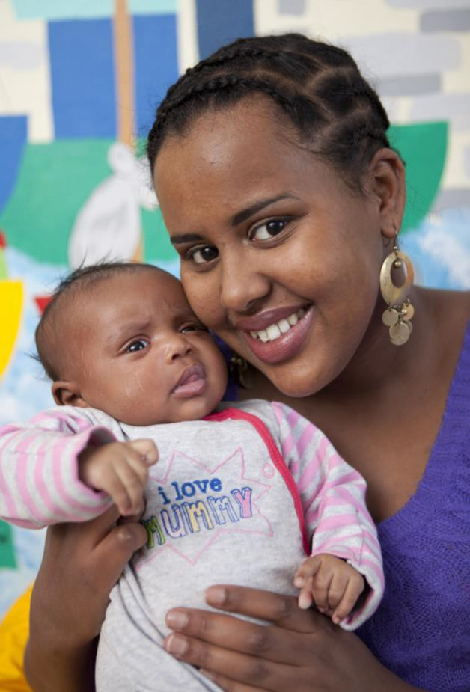


















Insert contact details here

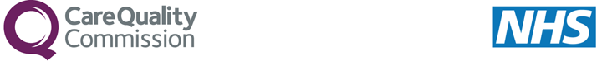

Women’s Experience of Maternity Care: 2017 Survey
What is the purpose of the survey?
It is very important for us to find out what different types of women across England think of the maternity care they have received. Your views are very important in helping us find out how good the maternity services are and how they can be improved. If you take the time to fill out the questionnaire the anonymous results will be fed back to the hospital, will be used in the assessment of the hospital and will feed into CQC inspections. They will also be published on the CQC website, so that other women planning to give birth can see the results.
Why have I been chosen?
You may be invited to take part in this survey in a few months’ time because you recently had a baby. We are sending questionnaires to other women who gave birth during the same time period. Questionnaires will be sent to women in April or May 2017.
Do I have to take part?
No. Taking part in this survey is voluntary. If you choose not to take part it will not affect the care you receive from the NHS in any way. If you do not want to take part in the survey, or to answer some of the questions, you do not need to give us a reason. If you do not wish to take part once you have received the questionnaire, you can return the blank questionnaire in the FREEPOST envelope or call the survey helpline number to tell us you do not wish to take part.
Will my taking part in this survey be kept confidential?
Yes. You will be given a unique number so your name and address will not be on the questionnaire, and your name and address will never be linked to your responses. Your anonymous responses will only be used to provide information about the quality of the services the trust provides and to help us to improve these services. All name and address information relating to this survey will be destroyed within a maximum of six months of completion of the survey.
Who is organising the survey?
The survey is being carried out by researchers from this NHS Trust (or independent contractor staff that they might employ), the Care Quality Commission and the Survey Coordination Centre at the Picker Institute Europe. The results will be presented in a form that does not allow any individual's answers to be identified.
What would I do if I do not want to receive a questionnaire?
You can decide not to take part in the survey once you have seen the questionnaire. However, if you do not wish your details to be shared with researchers so you can be sent a questionnaire, or if you have any questions about the survey, then please let us know by the end of March by contacting:

