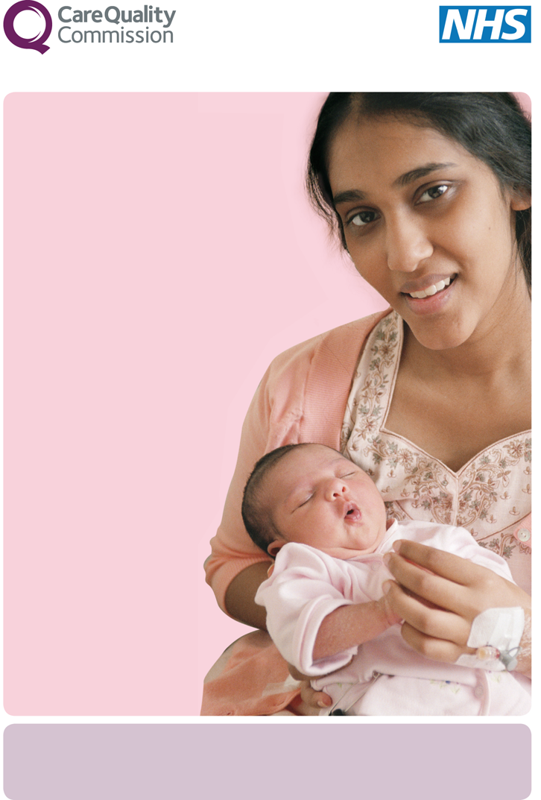

This trust will soon be carrying out a survey to find out **what service users think about the care**

**they receive**. This is part of a national programme to

improve quality of care and

service users’ experiences.

Taking part in the survey

is voluntary, and all

answers are confidential.

If you are selected to take

part, your contact details

will be used by researchers to

carry out the survey.

**National Community Mental Health Survey**

**Your views are important to us**

If you do not wish to take part, or have any questions about the survey, please contact: