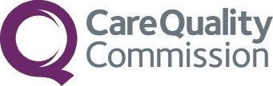

Your views are important to us
2018 Community Mental Health Survey

This trust will soon be carrying out a survey to find out what service users think about the care they receive. This is part of a national programme to improve quality of care and service users’ experiences.

Taking part in the survey is voluntary, and all answers are confidential.

If you are selected to take part, your
contact details will be used by researchers to carry out the survey.

If you do not wish to take part, or have any questions about the survey, please contact:

